Introduction
This project, Business Analytics Solution, focuses on building an end-to-end data model in Power BI to support business decision-making. Using the Medallion Architecture (Bronze, Silver, and Gold layers), raw data is cleaned, structured, and transformed into meaningful insights.

The solution includes creating key performance metrics such as Revenue, Cost, Profit, and Profit Margin, along with time intelligence measures like YTD, QTD, and LY comparisons. Forecasting techniques are applied to identify seasonal trends and predict future performance.

A Profit and Loss (P&L) visual and an interactive dashboard summarize all findings, enabling management to monitor results and make data-driven decisions effectively.

Objective of the Project

The objective of this project is to develop a business analytics solution in Power BI that converts raw data into actionable insights through data cleaning, modeling, and visualization. The solution ensures data accuracy and transparency, provides interactive visuals, and meets the company’s need for real-time performance tracking, forecasting, and strategic reporting.

Scope of the Project

The project covers the entire analytics workflow, from data extraction to dashboard creation, focusing on both technical accuracy and visual clarity. Key activities include:

- Implementing the Medallion Architecture (Bronze, Silver, Gold) for structured data flow.
- Cleaning and preparing data using Power Query for reliability and consistency.
- Creating dimension and fact tables for customers, branches, applications, and departments.
- Developing DAX measures for revenue, cost, profit, and time intelligence (YTD, QTD, LY).
- Performing forecasting analysis to predict future revenue trends.
- Designing visually rich and interactive Power BI dashboards that align with company expectations and support management in decision-making.

1. Understanding & Problem Statement
Step 1: Review the Dataset

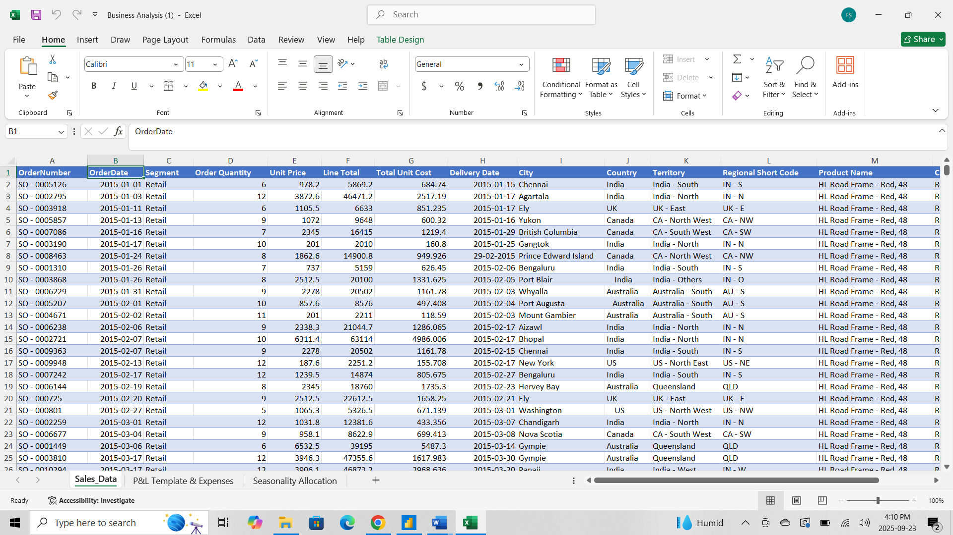

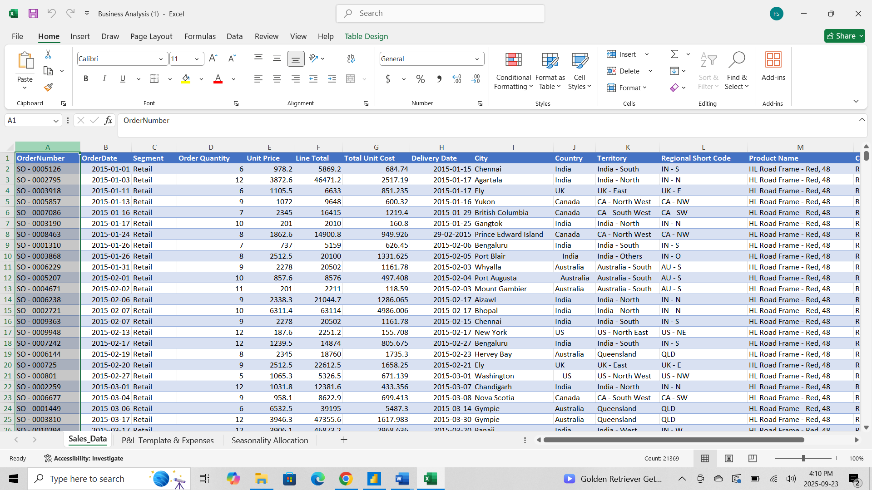
- Identified extra/unnecessary data at the end of the Sales Data sheet.
- Selected and deleted the extra rows to clean the dataset.
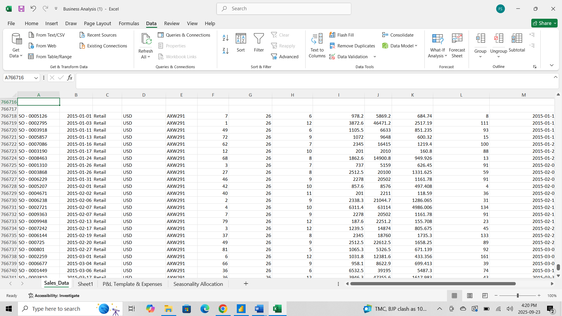

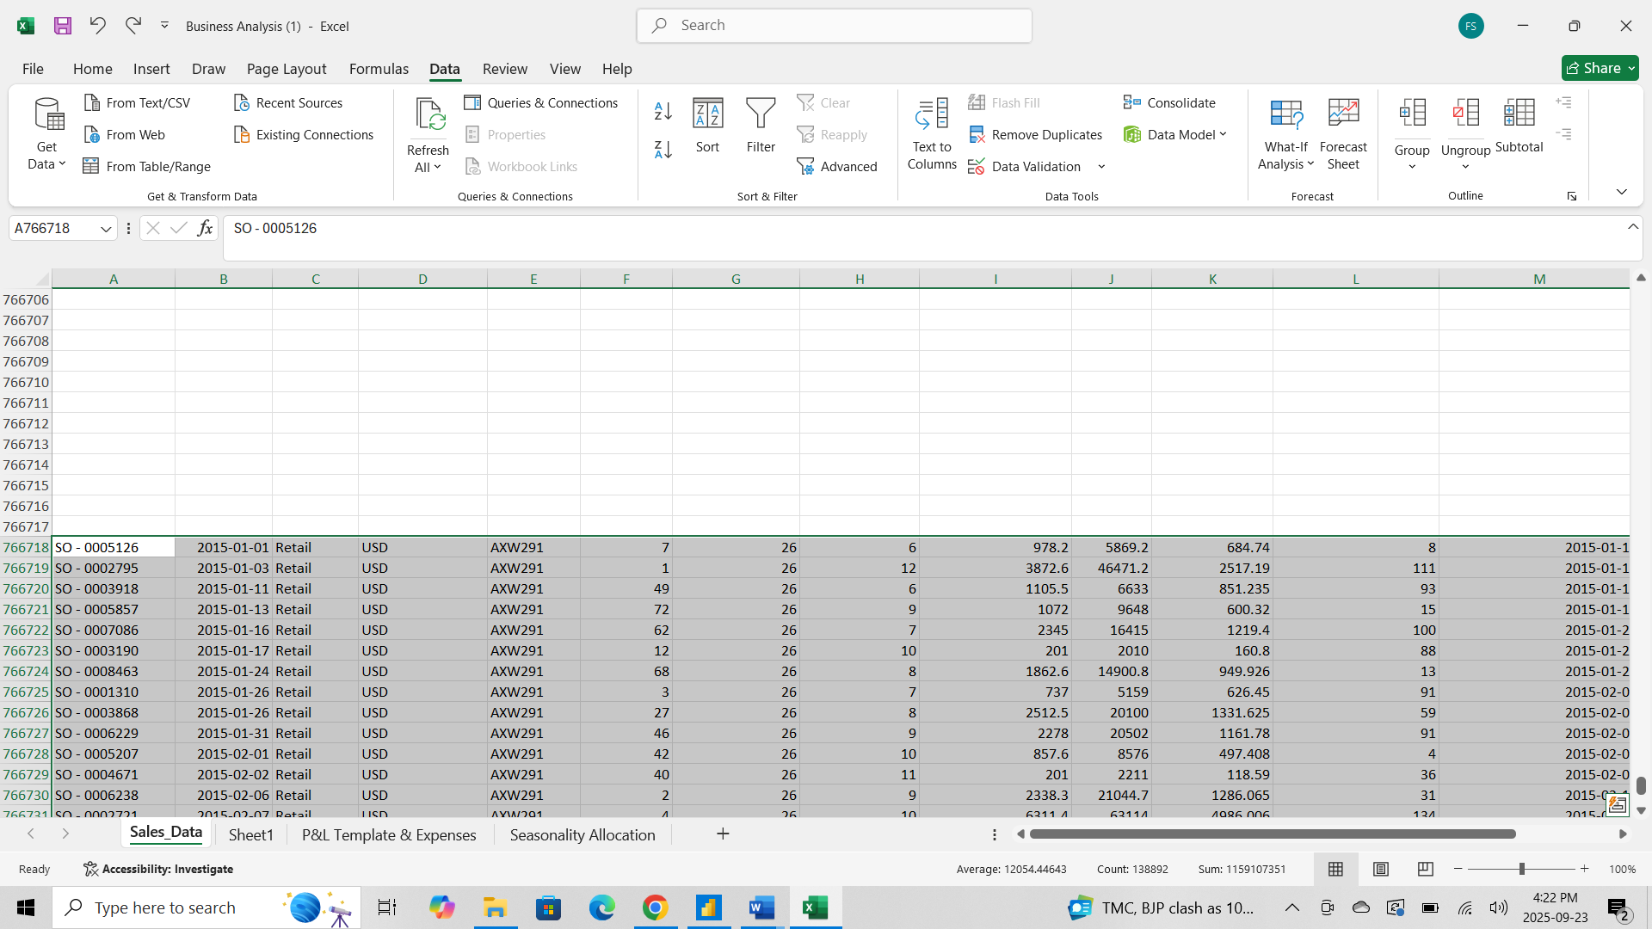

- Found extra item name details on the left side of the P&L Template and Expenses sheets.
- Removed unnecessary columns and kept only required data for the P&L analysis.
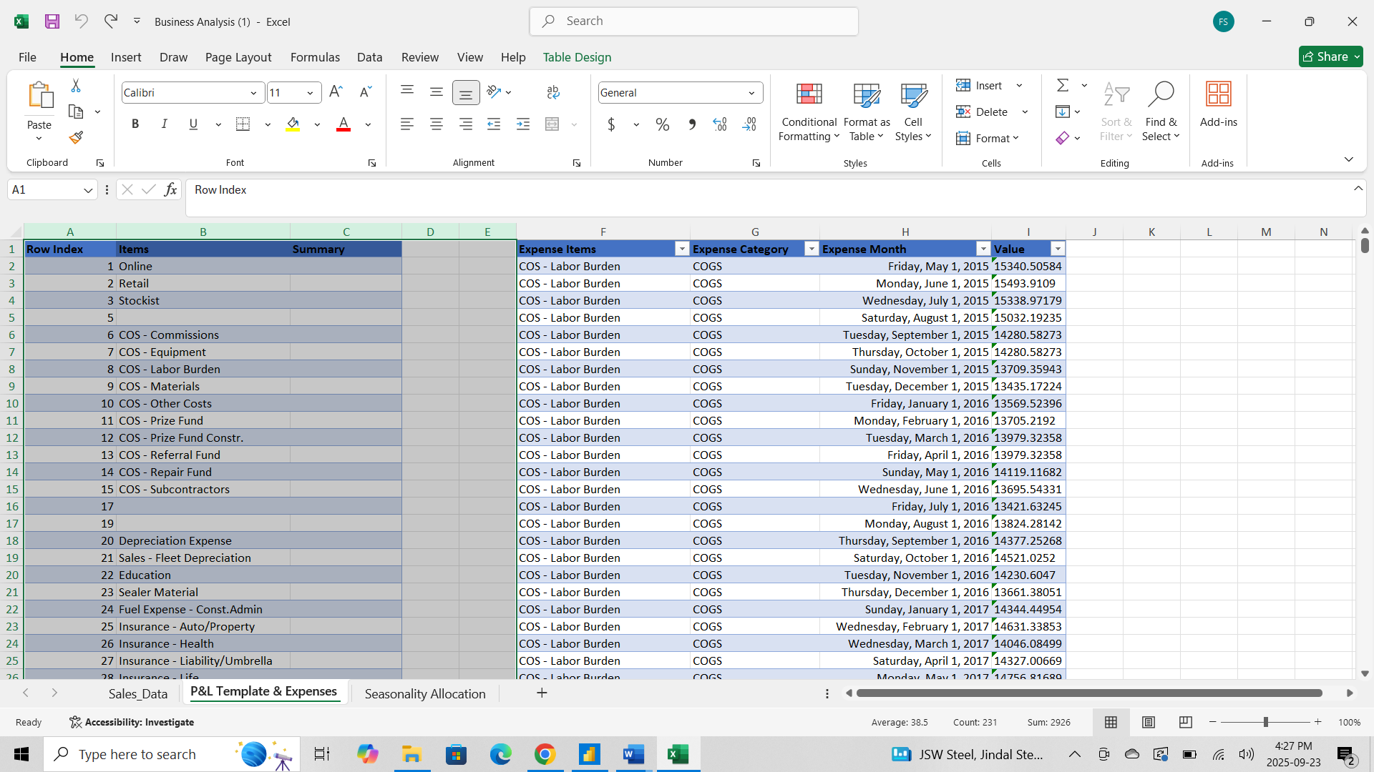
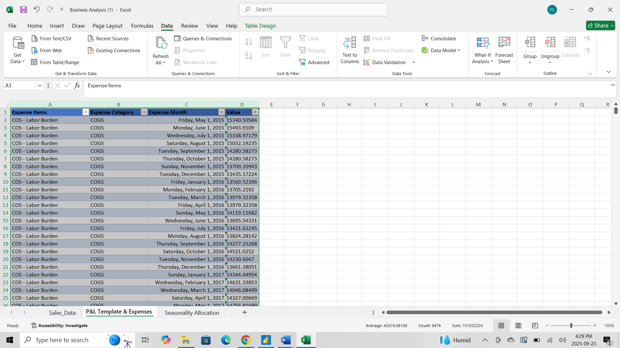

Power BI
- Adding Excel file into Power BI
- Open Power BI Desktop and save your file (File → Save) with a meaningful name.
- Home → Get data → Excel.
- Browse to and select Business Analysis.xlsx file → Open.

- In the Navigator window, check the sheets or named tables you want to import (click each to preview)
- We want to clean/transform first: click Transform Data (this opens Power Query Editor).

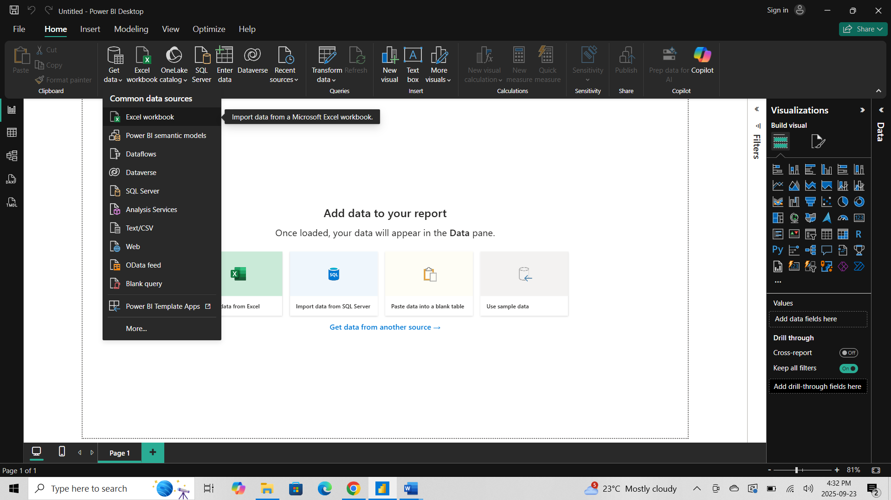

Transform Data
- Go to Home → Click Transform Data to open Power Query Editor.
- Select the table containing your Date column.
- Select the Date column you want to modify.
- Replace Value:
- Go to the Transform tab → Click Replace Values.
In the dialog box:
Value to Find: 29/02/2015
Replace With: 29/01/2015
- Click OK.
- Check the column to ensure the change is applied correctly.

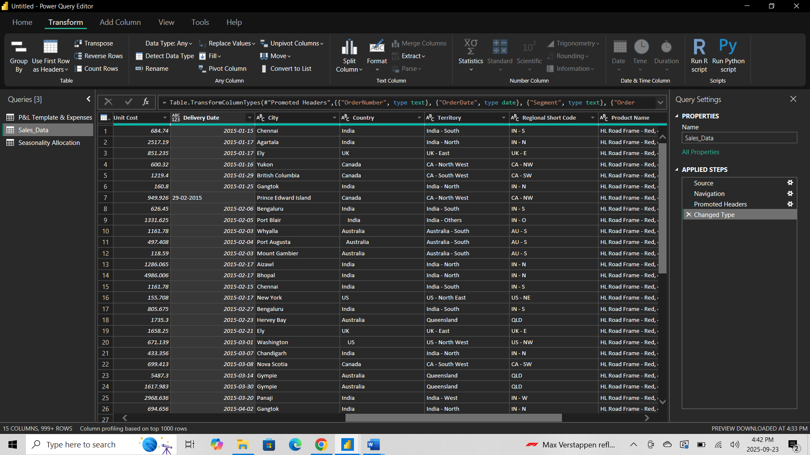

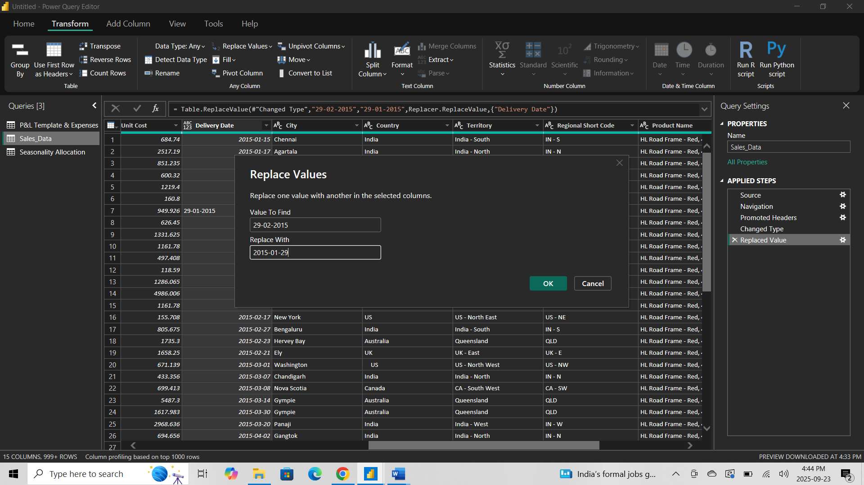

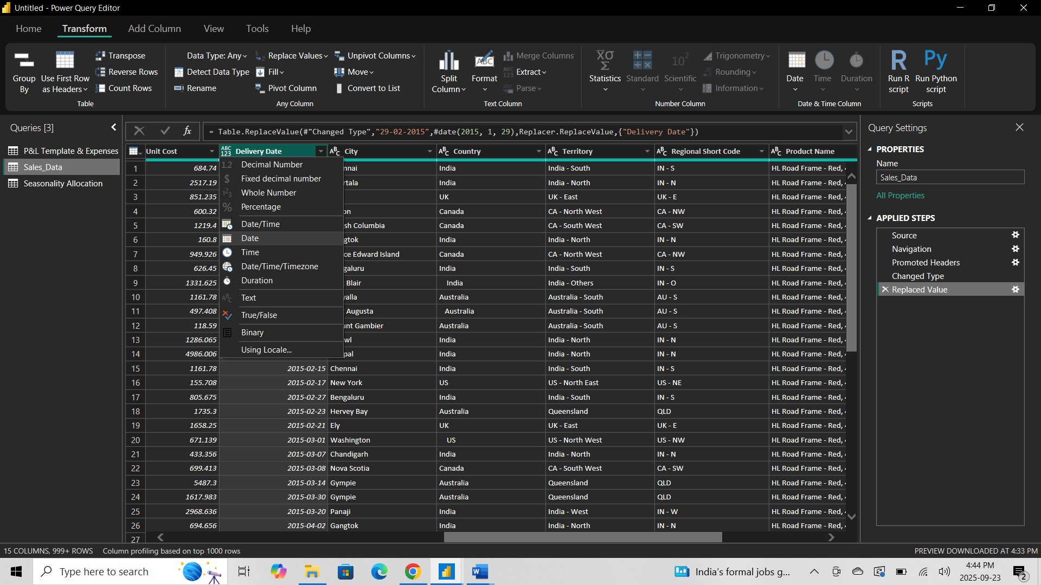

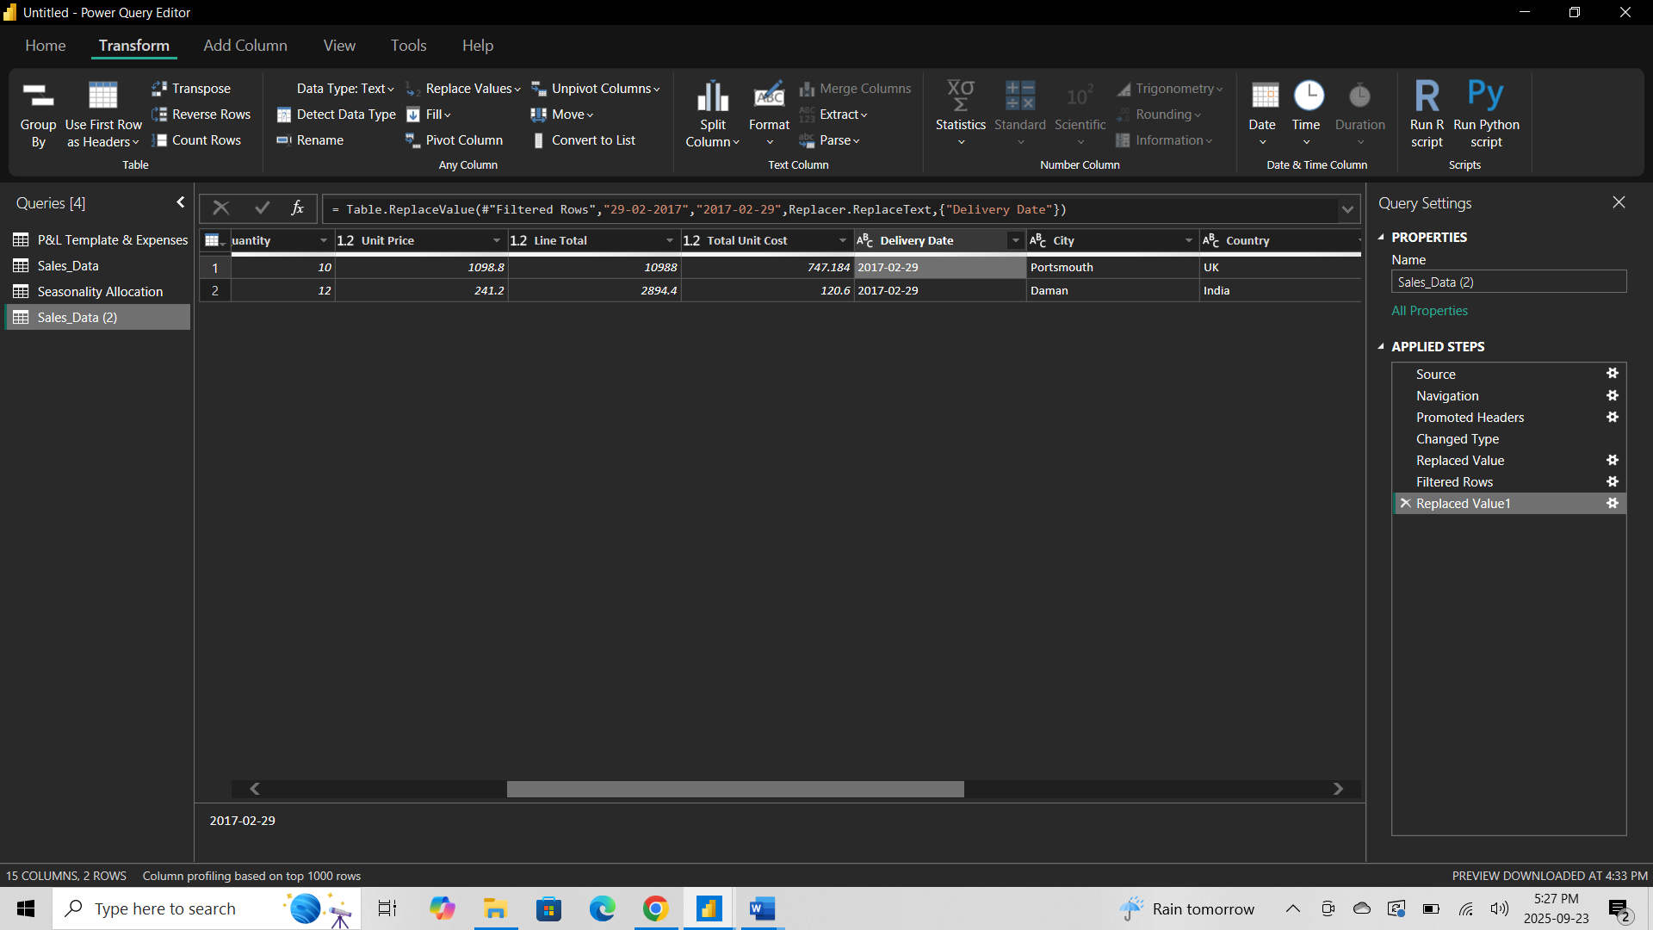

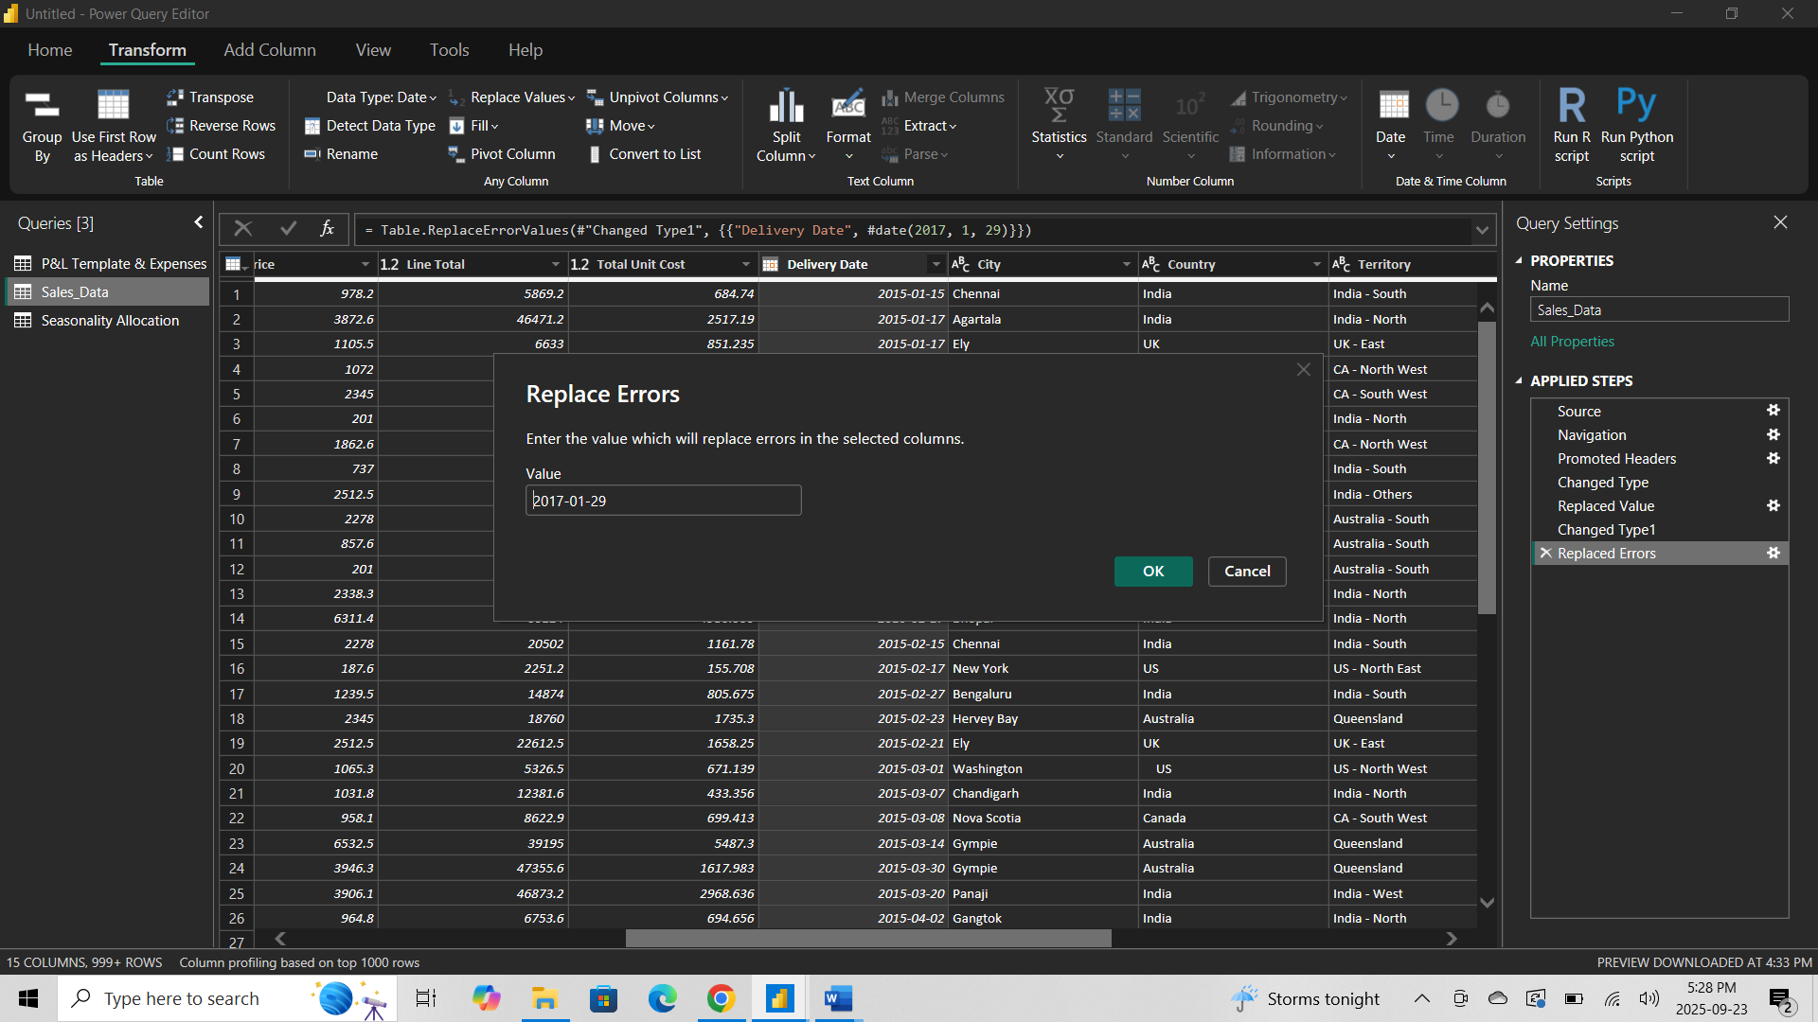

- Trim the data:
- Click Format → Select Trim.
- This removes all leading and trailing spaces in the Country column.
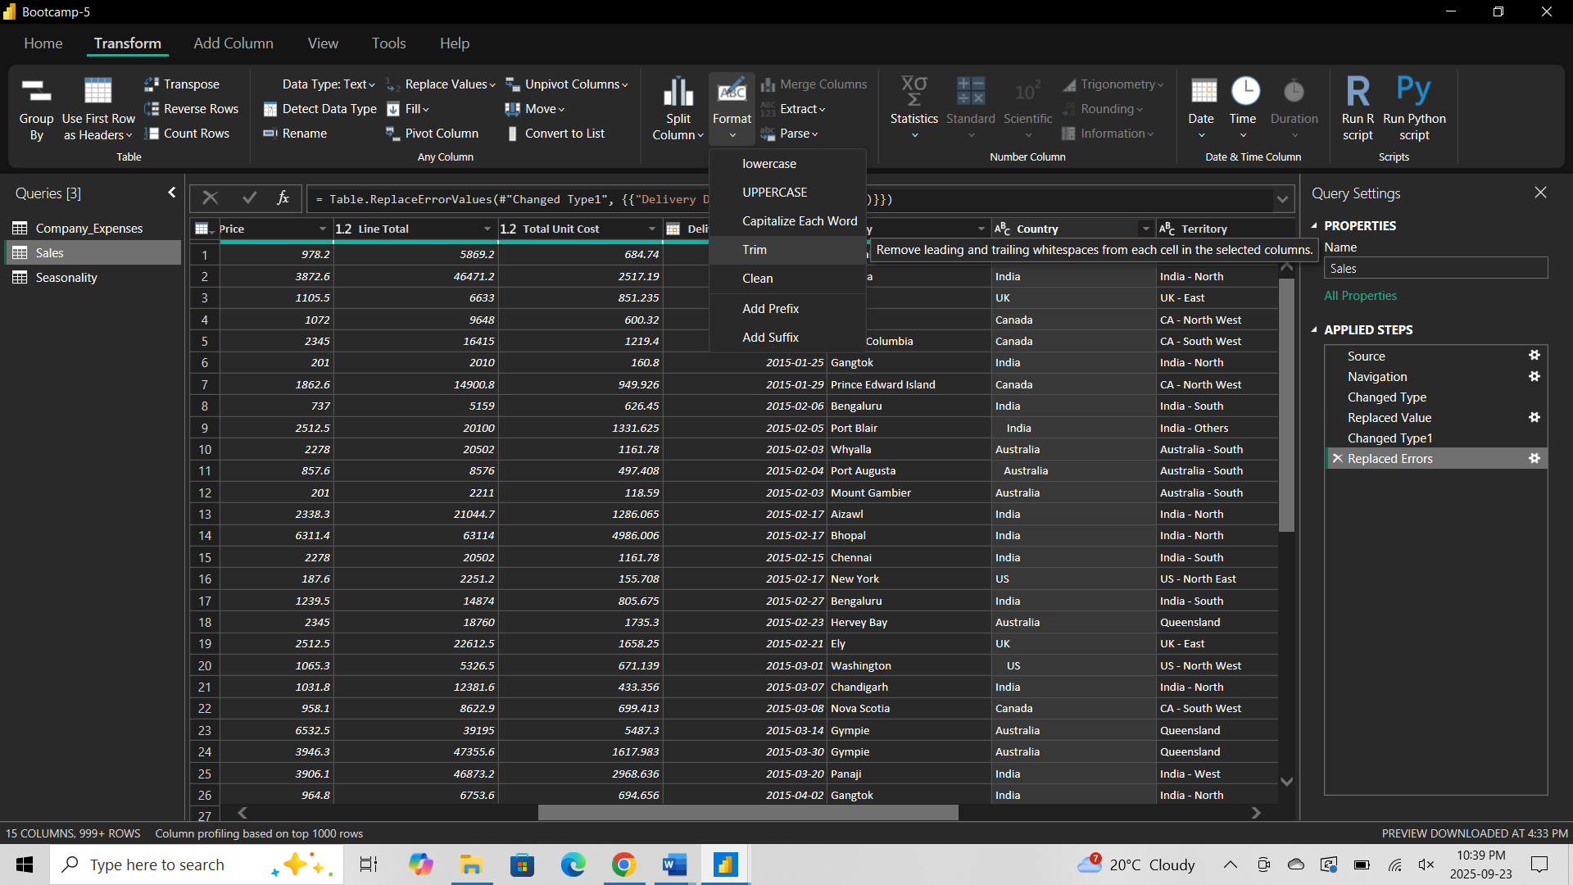

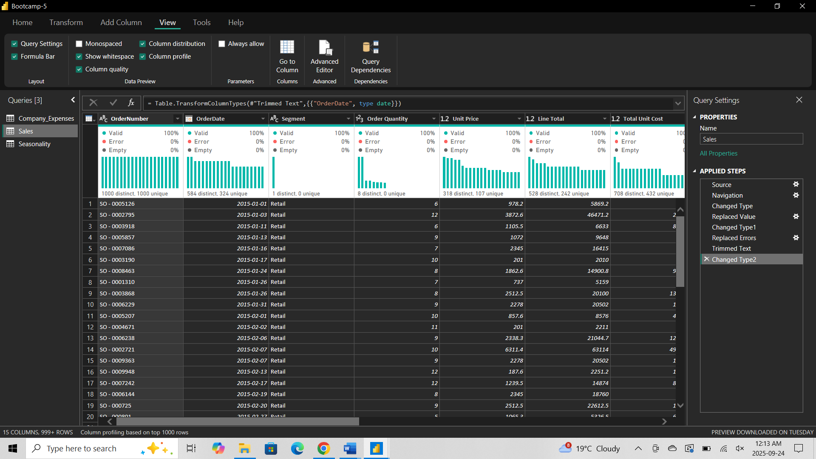

ER-Diagram
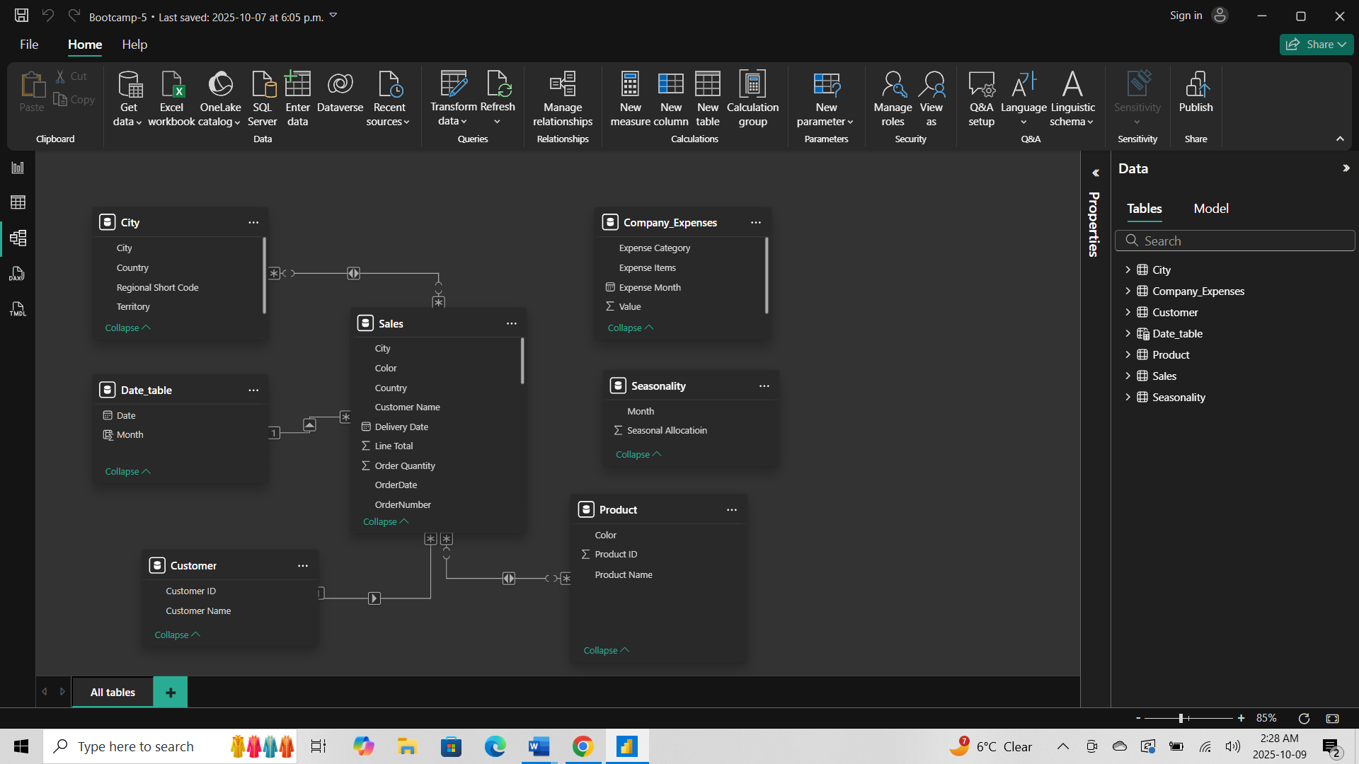

- Create a New Measure:
- Go to the Modeling tab → Click New Measure.
- Total_Revenue = SUM(Sales_Data[line Total])
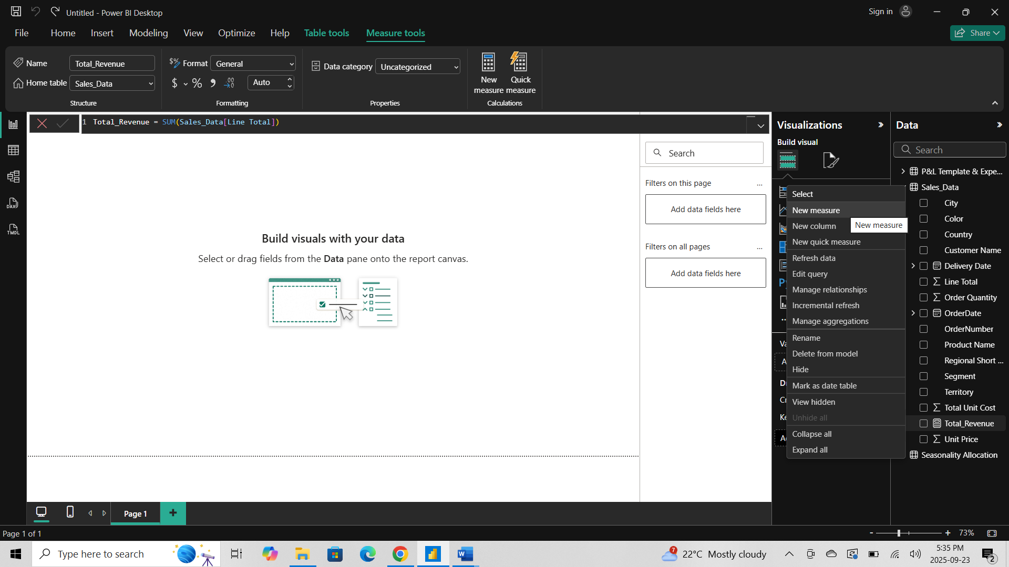
- Total Cost = SUM(Sales,Sales[Order Quantity]*[Total Unit Cost])
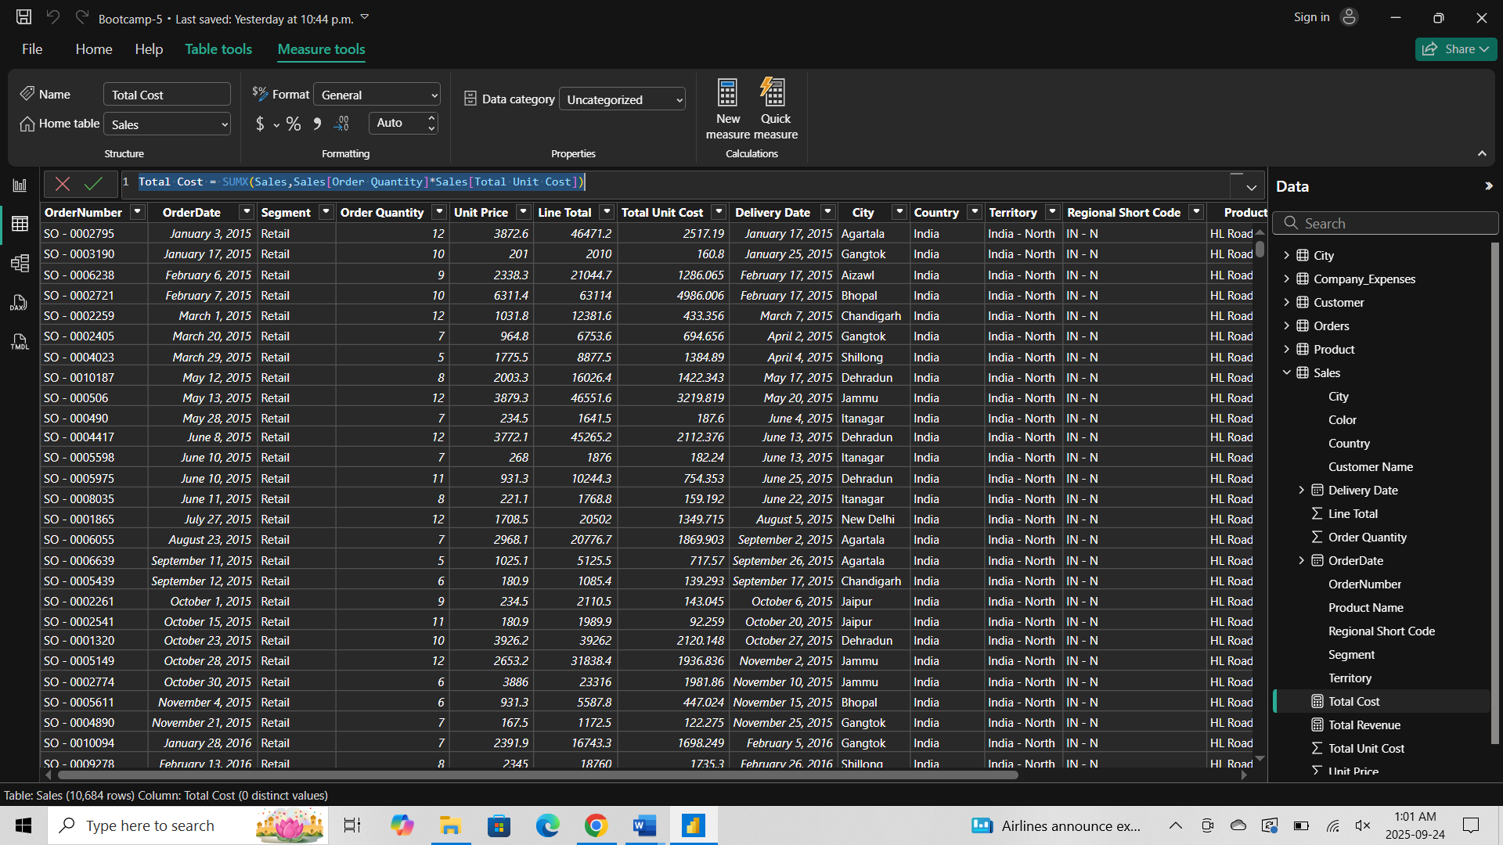
- Total Profit = [Total Revenue] – [Total Cost]
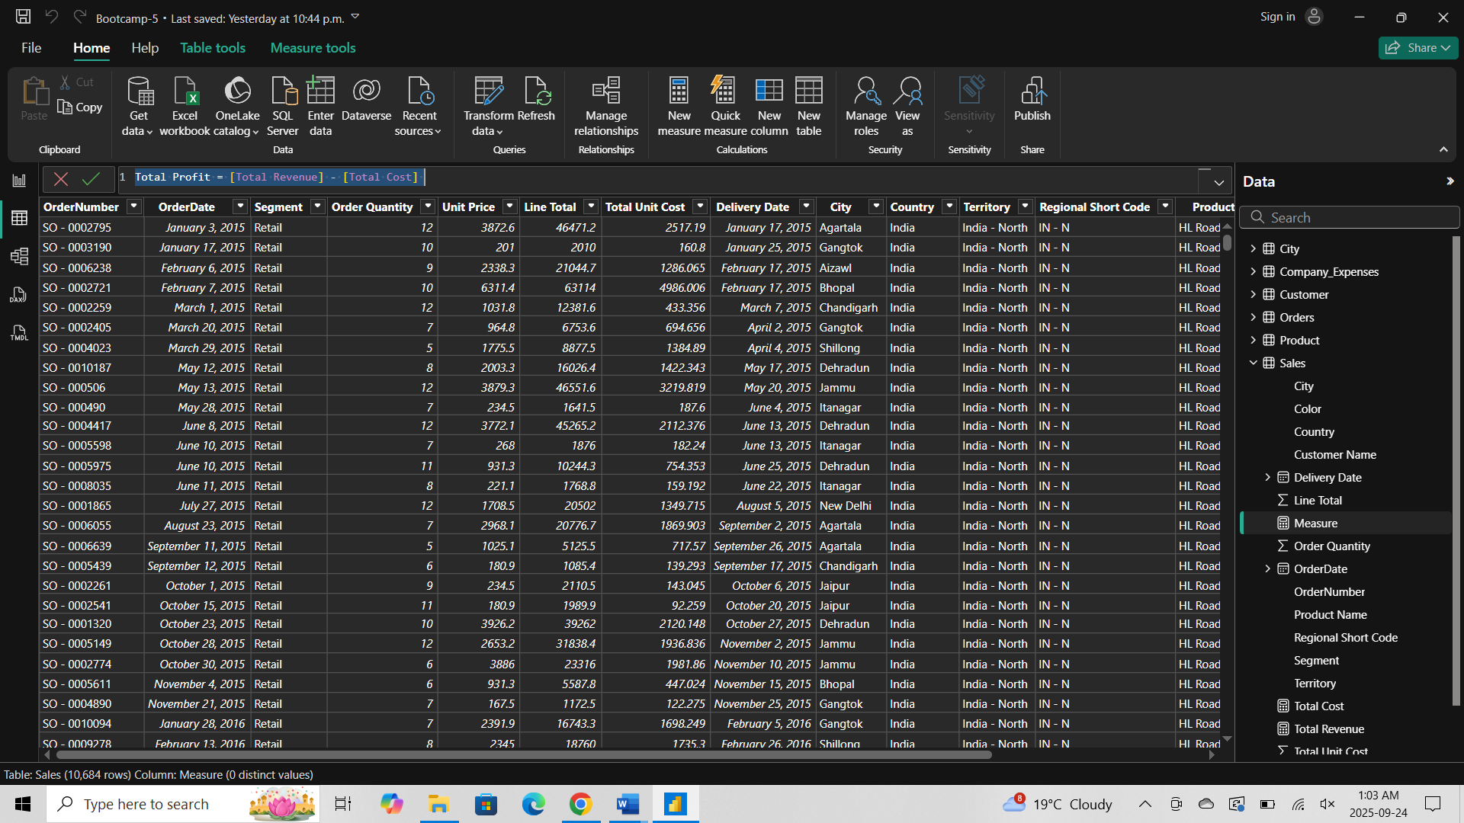
- Profit Margin = [Total Profit] / [Total Revenue]
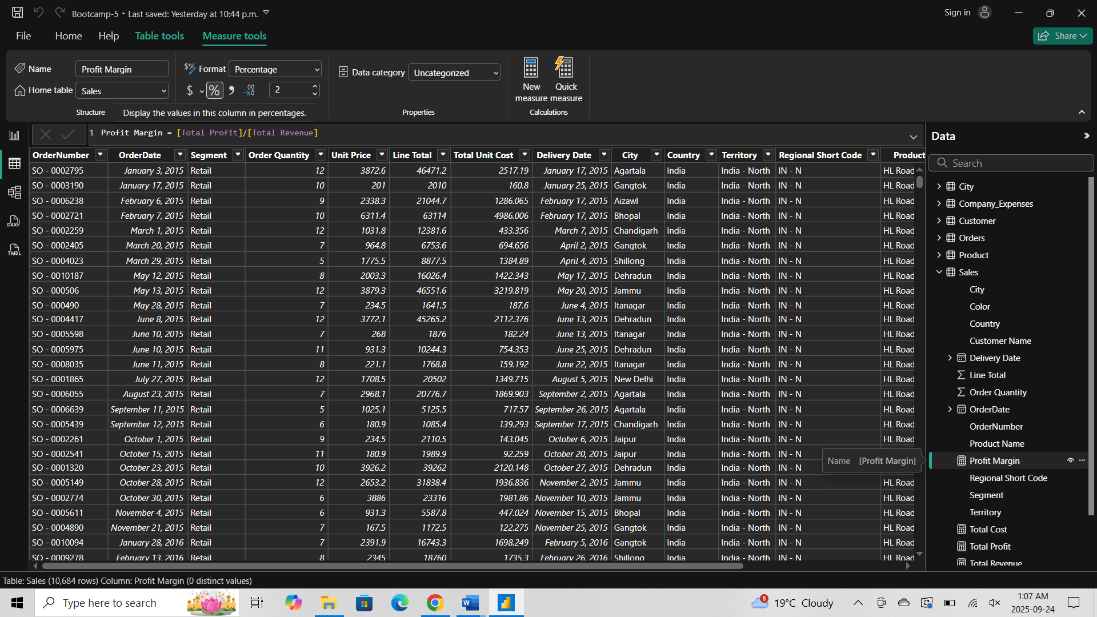

KPI
- Aggregation & Calculations (Gold Layer)
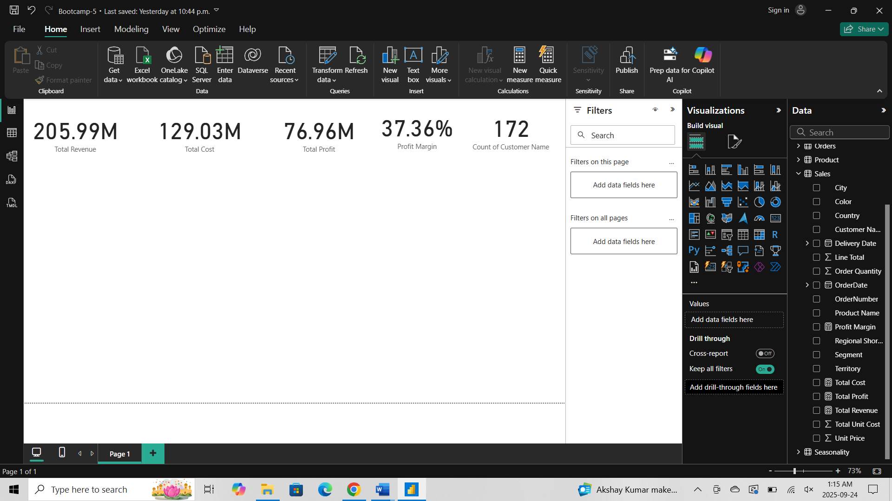
- Time Intelligence DAX
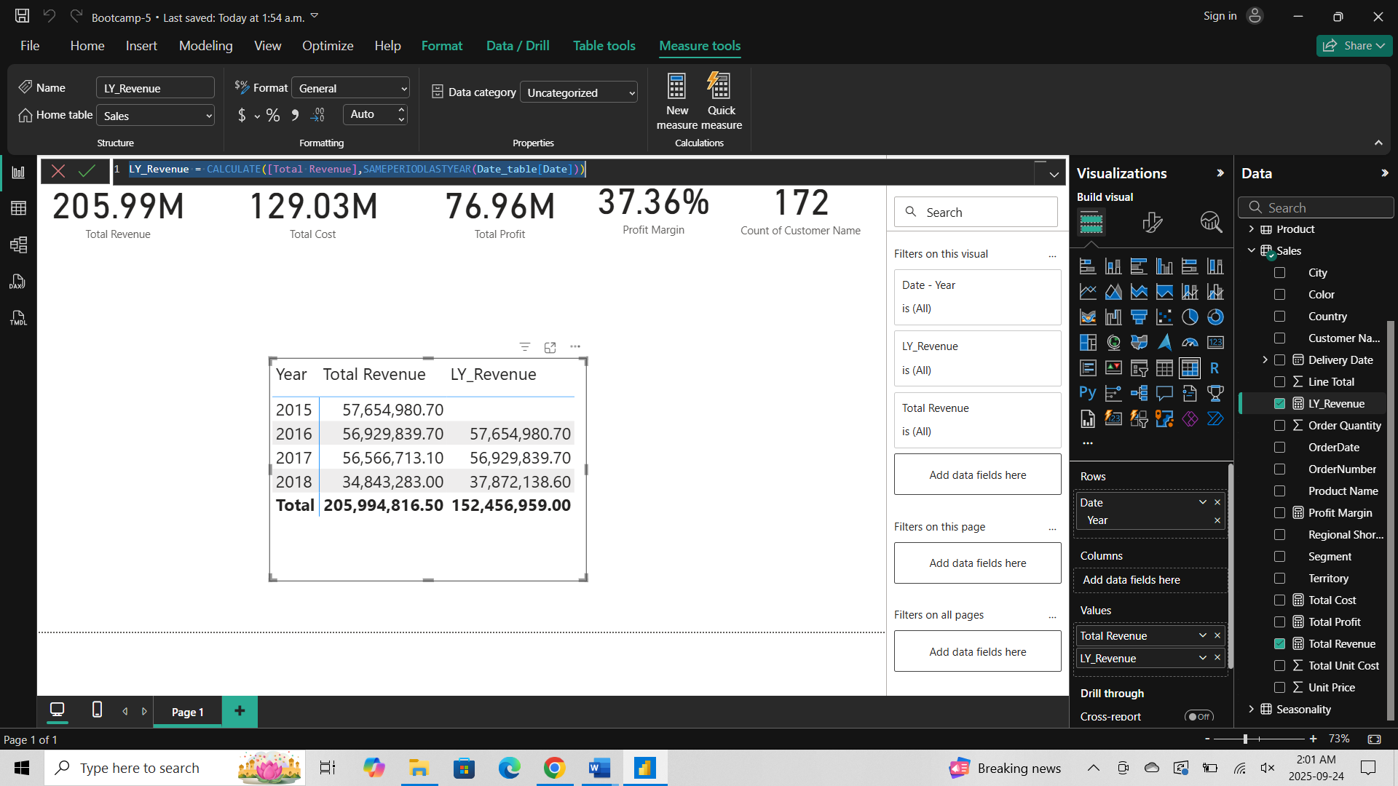

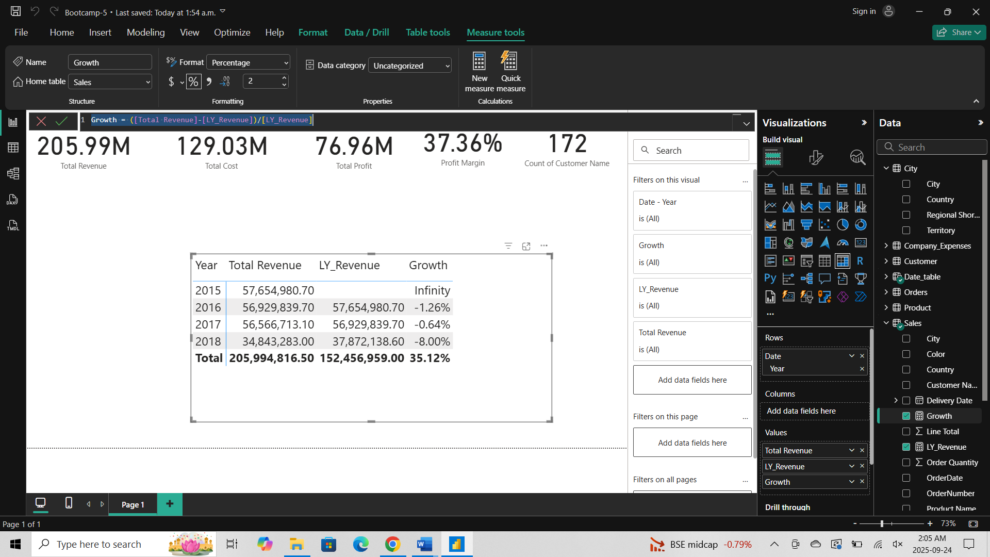
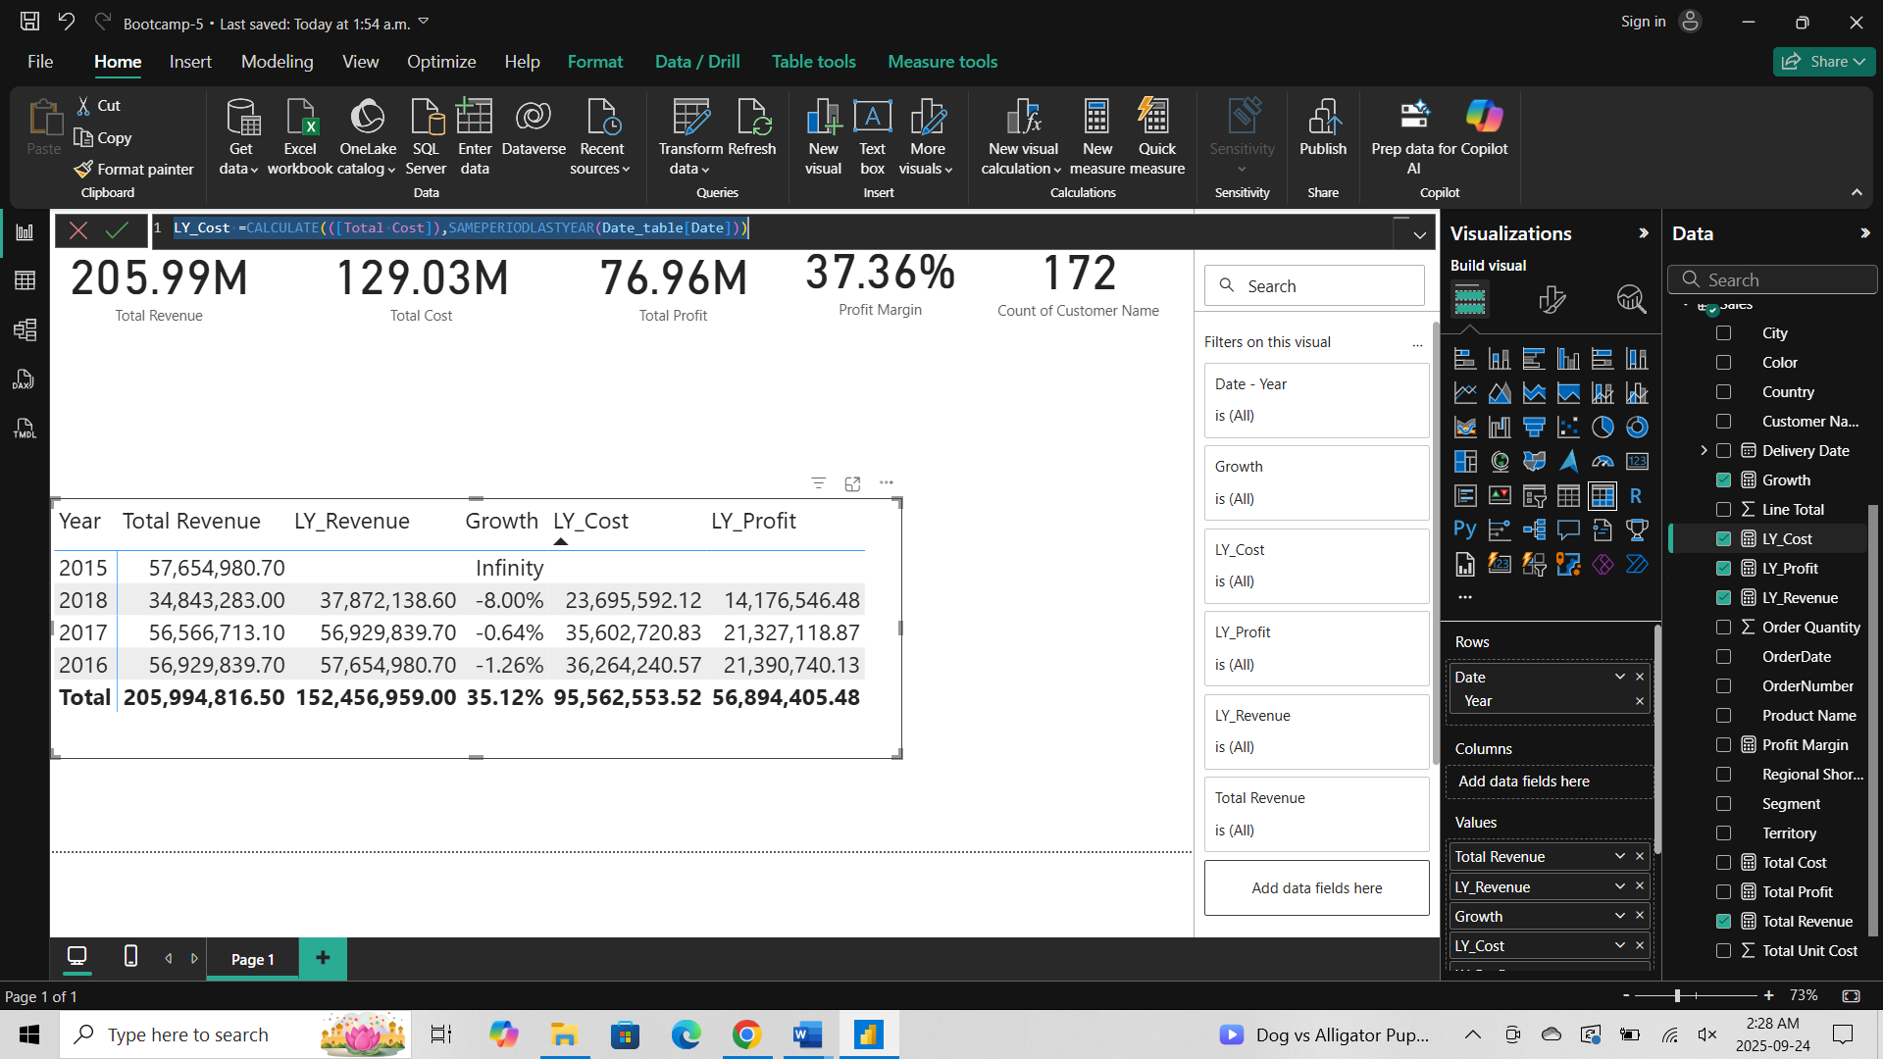
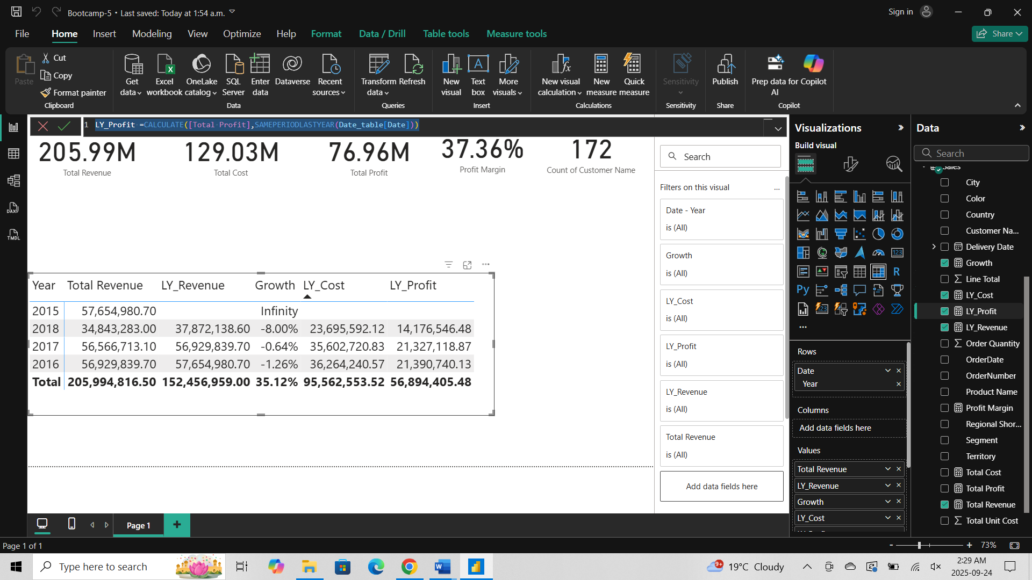

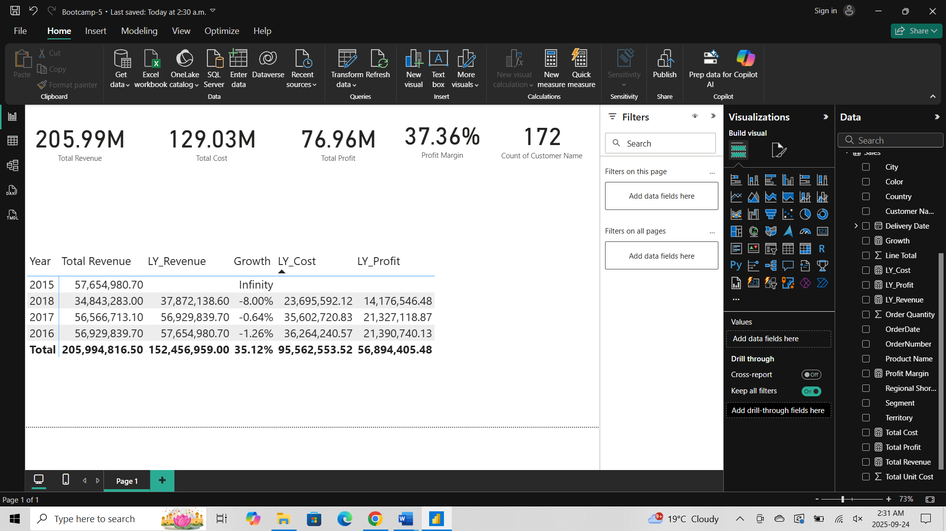

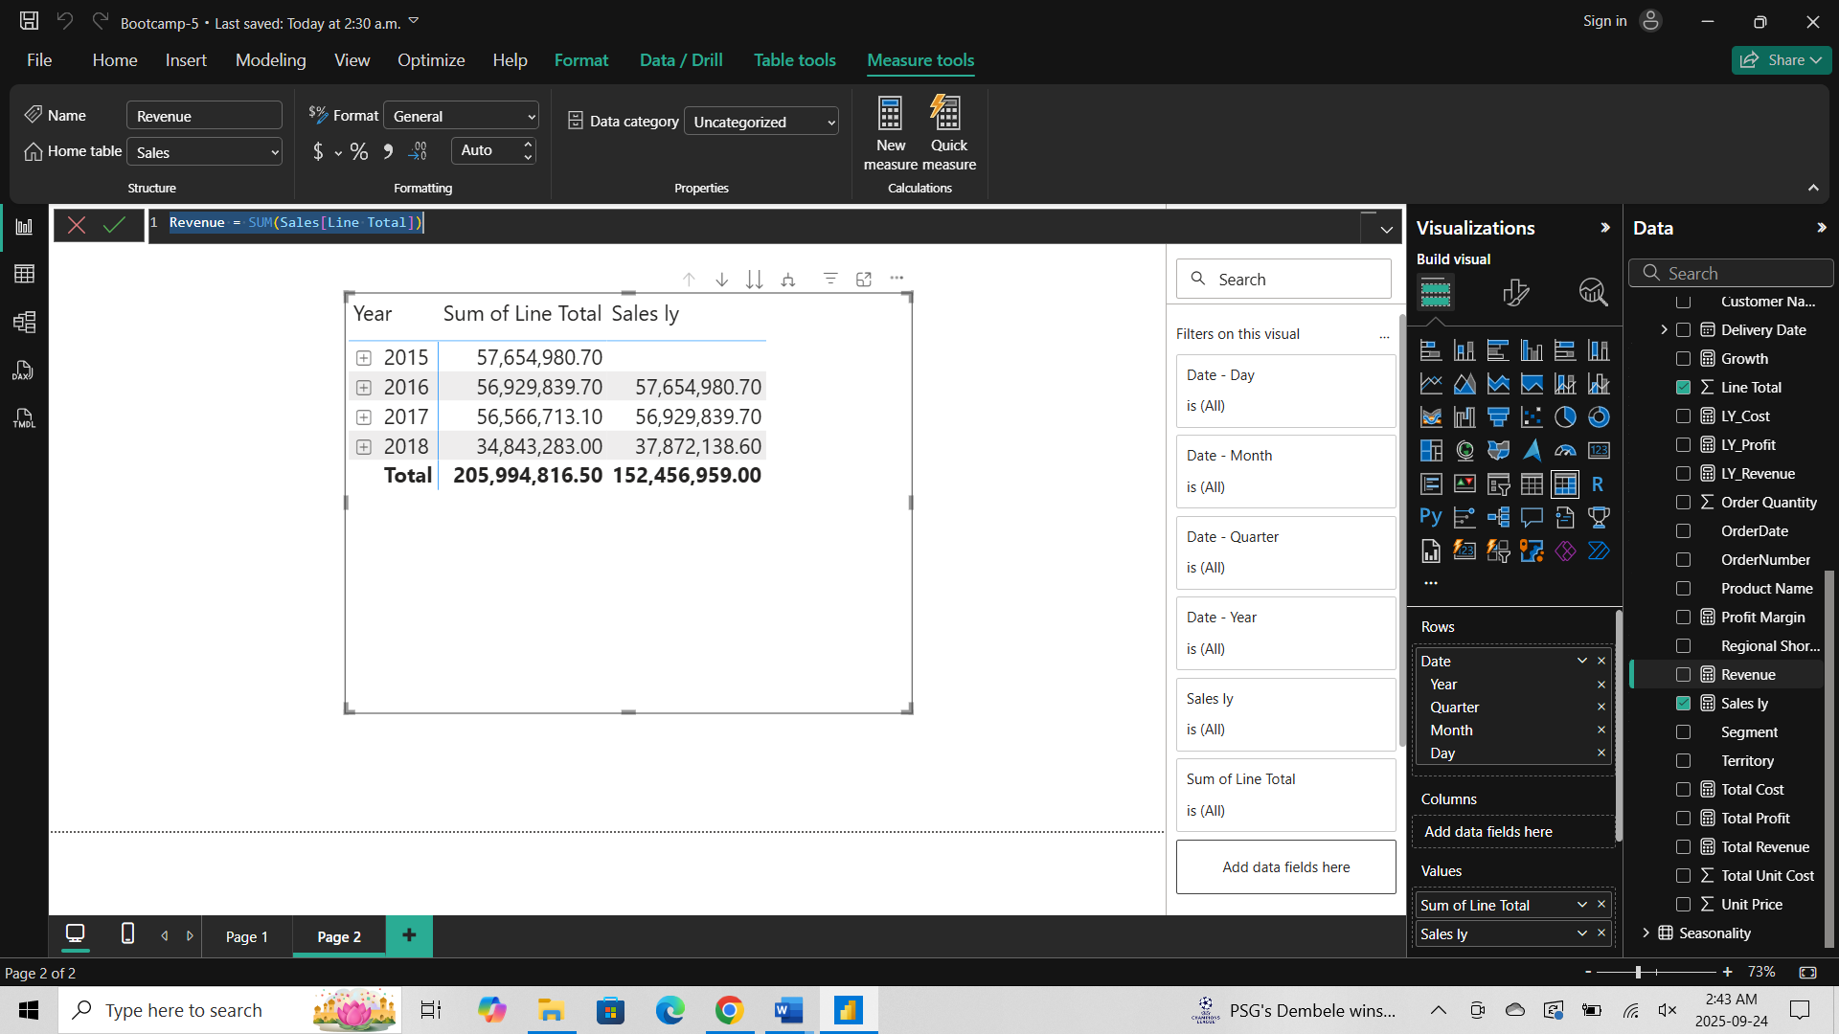
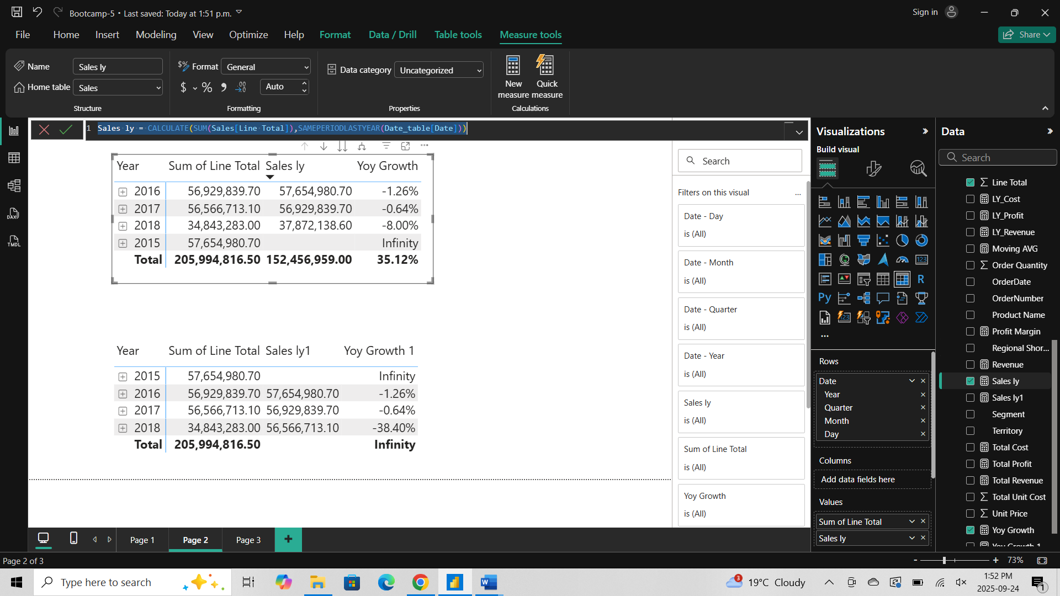

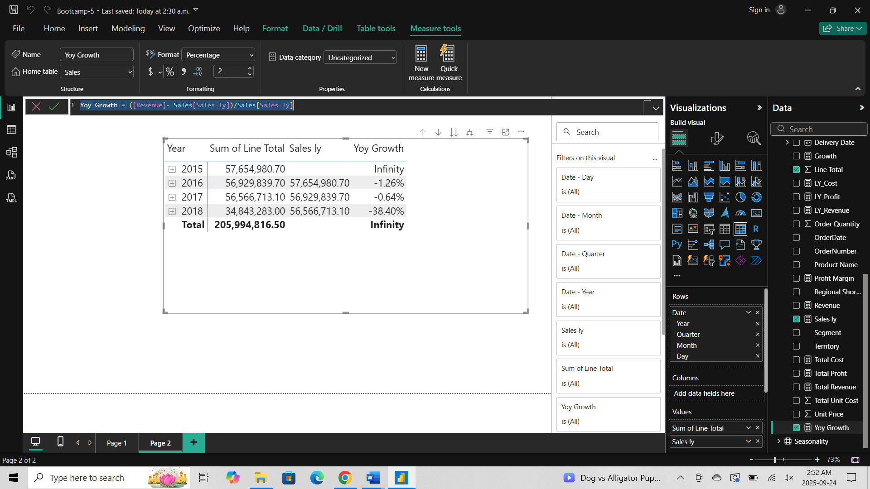

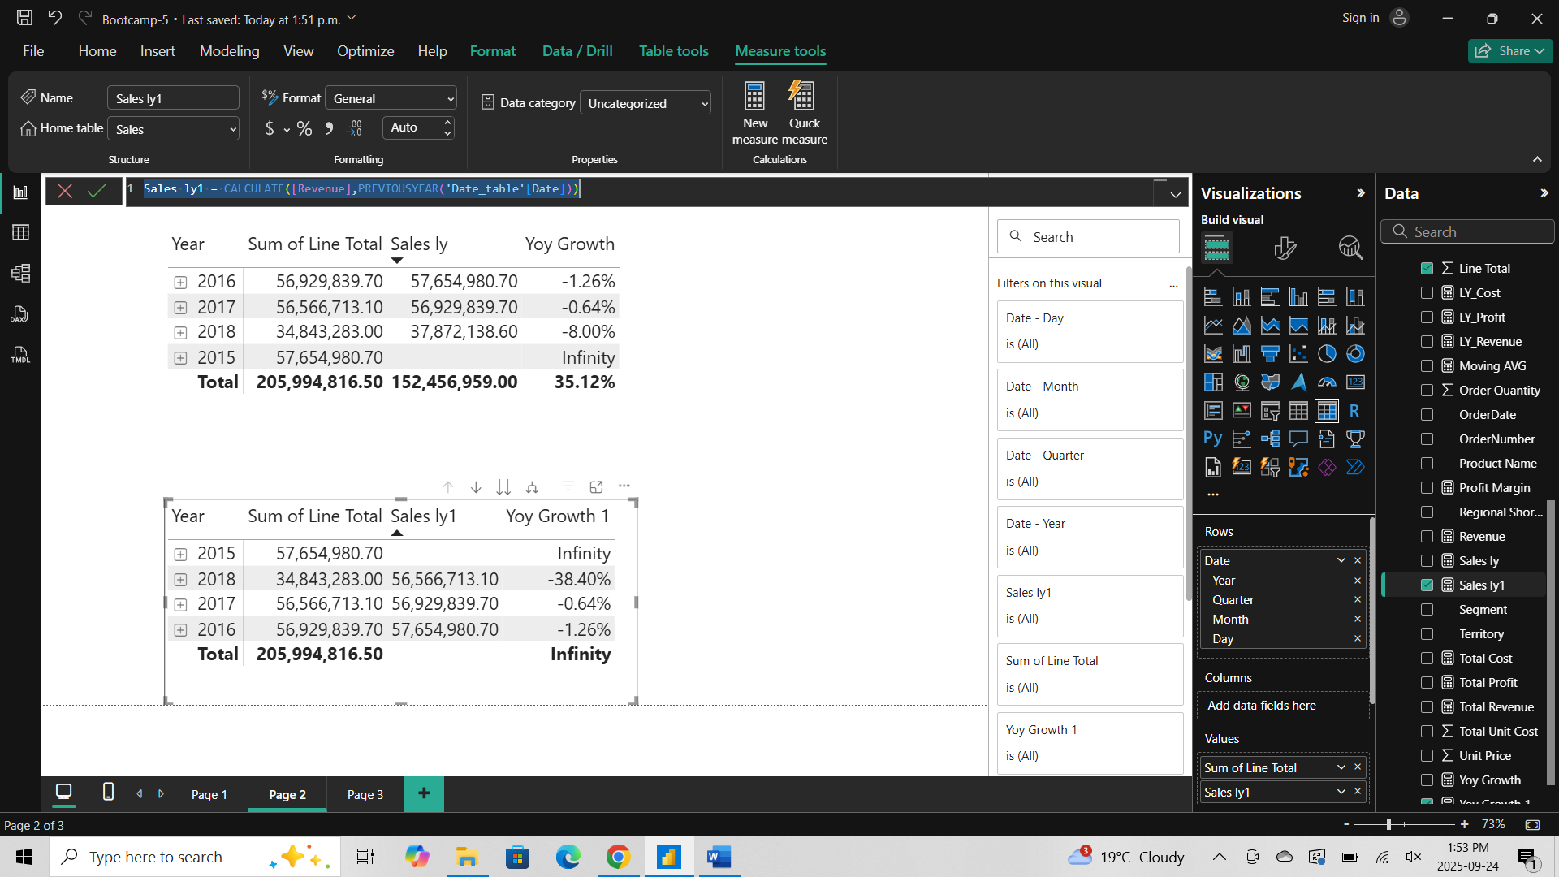

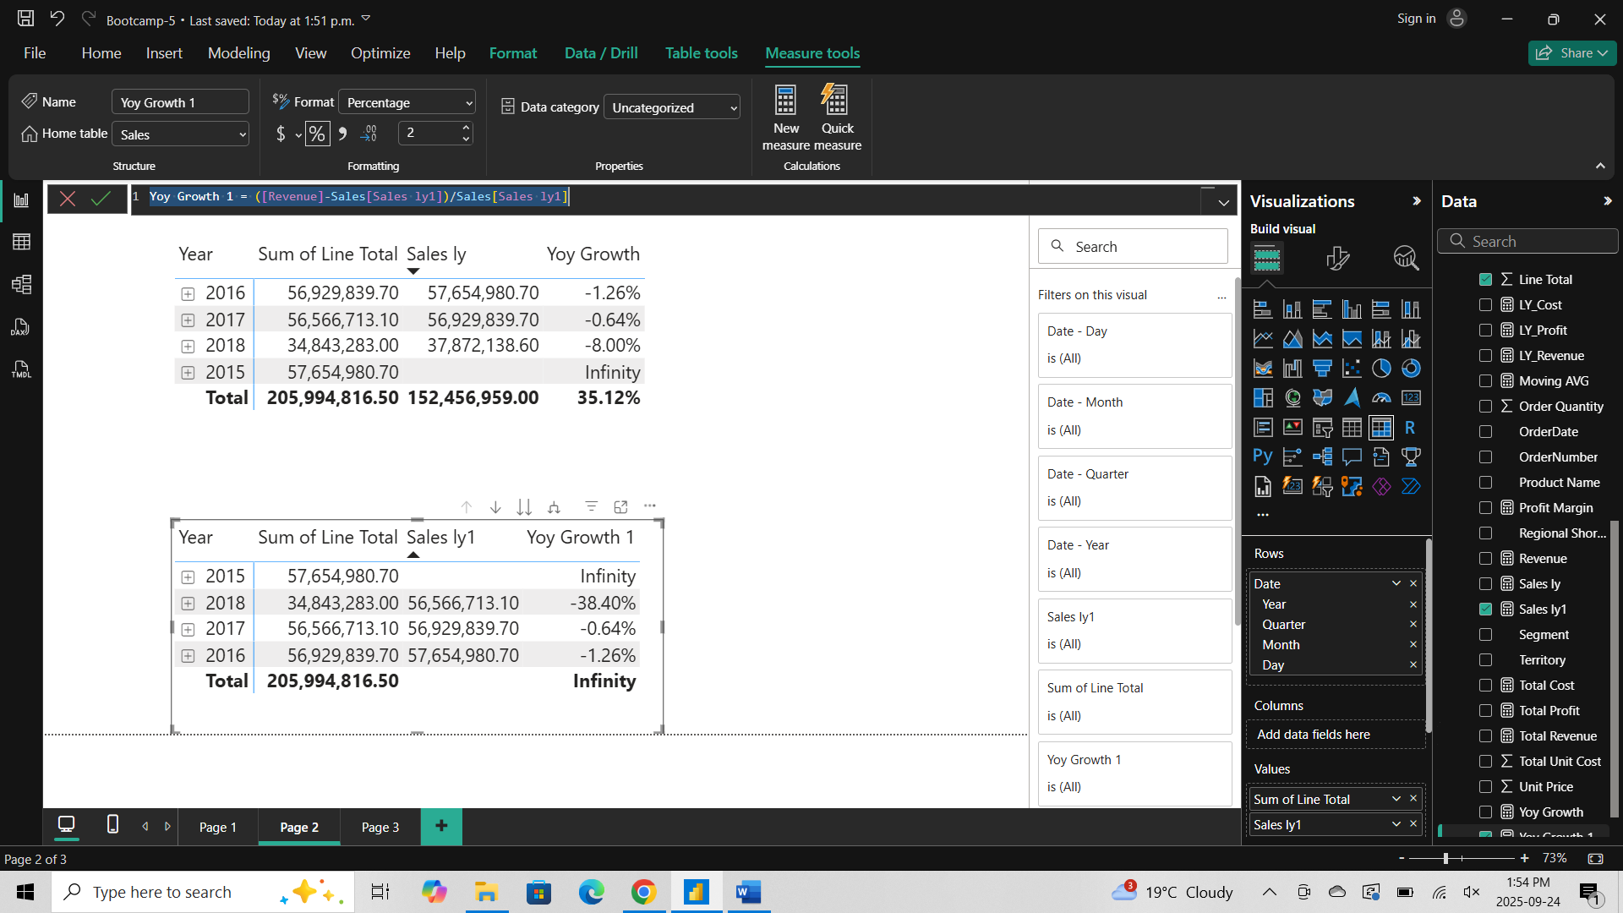

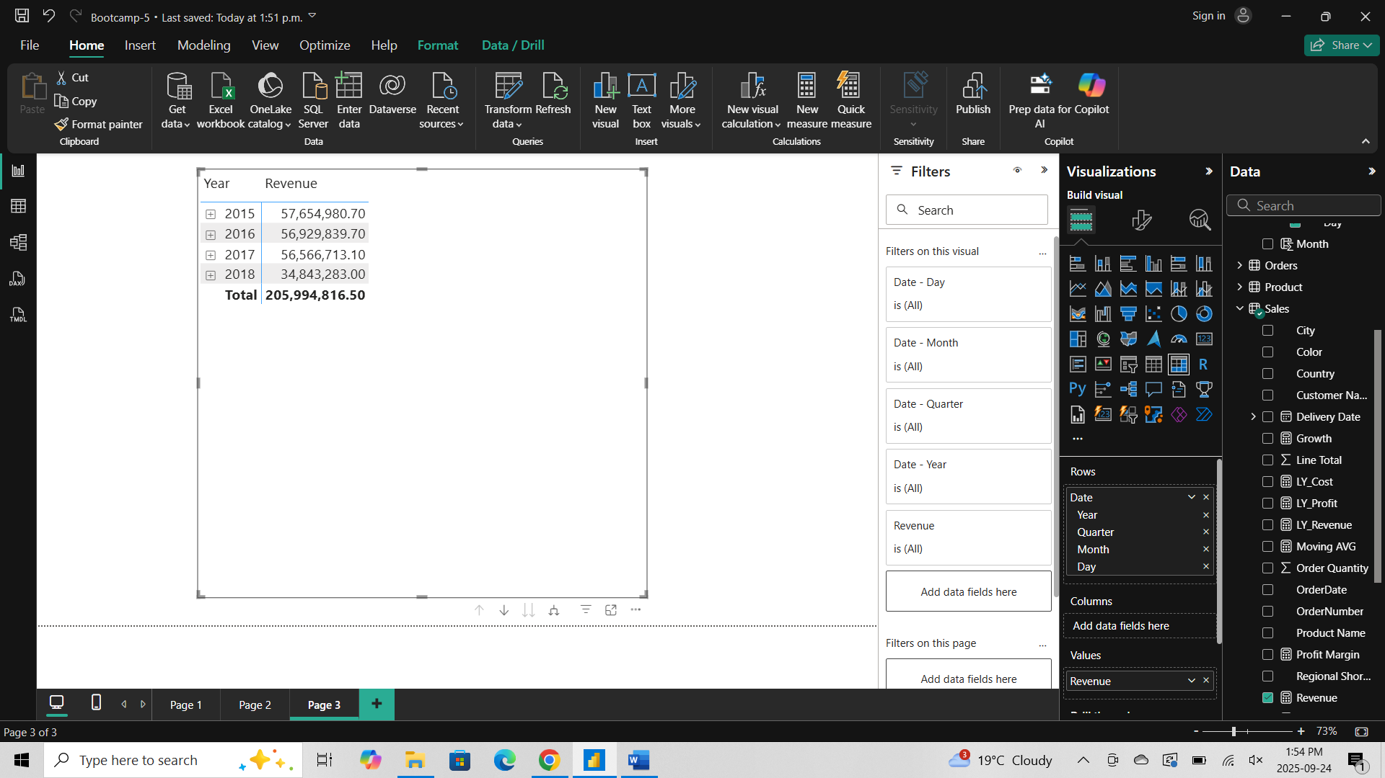

- Time Intelligence Calculations
- Prepare Date Table
